Bitcoin Notes

Two indecators of interest

Newple : Net Unrealized Profit and Loss(found on glass note, paid)

Tracks how many holders a crypto currency are in profit

<https://glassnode.com/>

Puell: multiple tracks the revenue of miners and pairs it to price action – lookingtobitcoin.com

Dips in the Puell multiple proceed dips in Network difficulty by a few days

**The Puell Multiple**

Chart Formula

Hash rate changes proceed network difficult changes directly

In the field of data visualization, Python offers a host of top-notch graphing libraries such as:

* Pandas Visualization
* Matplotlib
* ggplot
* Seaborn
* Plotly

Predictive modeling:

we’ll want to evaluate its accuracy using a cost (or loss) function. This is also commonly referred to as the mean squared error (MSE)

* *i*represents the index of the sample,
* y-hat is the predicted outcome,
* y is the actual value, and
* *m* is the number of samples.

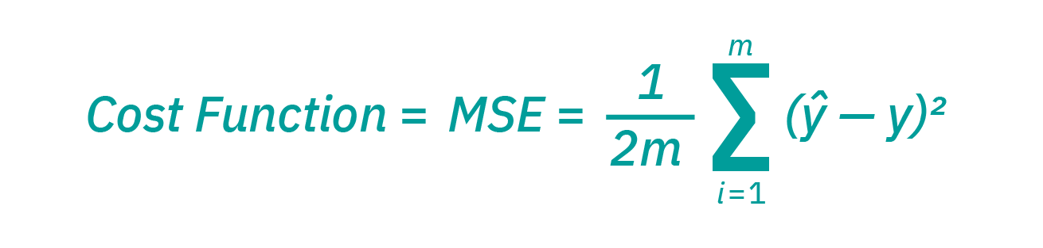

Types of models

* Time-series regression analysis is a method for predicting future responses based on response history
  + Can be used to model data that happen according to a certain time
  + Typically used for weather, tides, i.e. things dependent on time
  + Can be used in models to accurately predict periodic mine sell offs but also importantly past and future bitcoin halving events
  + Autocorrelation, sometimes known as serial correlation in the [discrete time](https://en.wikipedia.org/wiki/Discrete_time) case, is the [correlation](https://en.wikipedia.org/wiki/Correlation) of a [signal](https://en.wikipedia.org/wiki/Signal_(information_theory)) with a delayed copy of itself as a function of delay. (good method to possibly identify or filter out spikes from miner sell offs)
* Ridge regression is a technique for analyzing multiple regression variables that experience multicollinearity.
* Linear regression is to be used when the target variable is continuous and the dependent variable(s) is continuous or a mixture of continuous and categorical, and the relationship between the independent variable and dependent variables are linear.
* Neural Networks algorithms are modeled loosely after the human brain and are designed to recognize patterns.
  + Comprised of several layers of nodes that represent neurons in the human brain
  + Each neuron is connected to other neurons that follow a certain order(typically input left output right)
  + Each node has an associated weight and threshold
  + A node will only output if the thresholds are met from the inputs of other nodes
  + each Node has a function that takes the input data from other nodes, weights it , and summizes it with all the other data it has received,
  + Once run through a activation function the output of the summized function will determine if the node threshold fires and outputs data to the next level of nodes or not
  + Creating nodes that perceive the output of its MSE function that high or low that fire for the next series of inputs helps the program remember if its function is accurate or not and to weight its future outputs differently based on that input
  + Thought of as a matrix of decision represented by nodes